*Florida International University*

*School of Computing and Information Sciences*

Software Engineering Focus

Feature Document

User Story ID <787>

**User Story Name: Parse User Commands**

* Description: **As a developer I want to parse user commands so that I can test user input for correctness.**

Acceptance Criteria

* Character’s moves match user input
* Player received feedback whether they passed the level or not

**Use Case**

* Name: User submits solution
* Actor: Player
* Preconditions: User has selected a sequence of instructions
* Description <The player has chosen instructions for the solution and has placed them in the sequence he wished them to be executed. Player will receive feedback of whether the solution is correct or incorrect. >:

**Use Case Diagram**

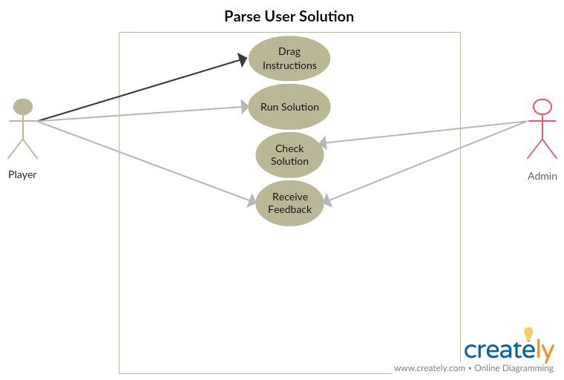

**Sequence Diagram** 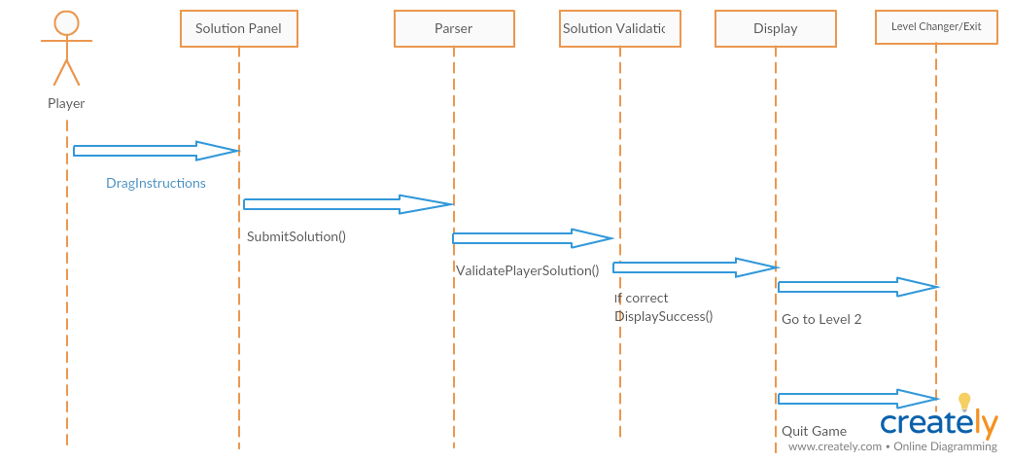

**Class Diagram** 